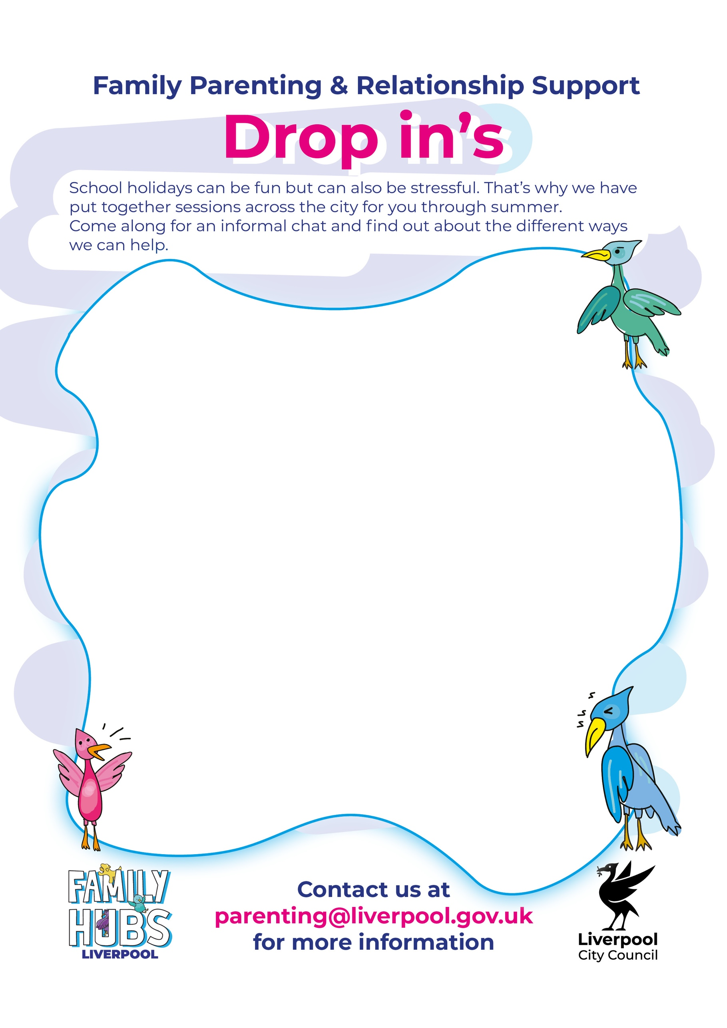
Breck Road Library
Breck Rd, Liverpool L5 6PX
Phone: 0151 263 6116
29 July 12pm-2pm
12 August 12pm-2pm

West Derby Library
West Derby Rd, Tuebrook, Liverpool L13 7HQ
Phone: 0151 233 3069
06/08/25 12pm-4pm
20/08/25 12pm-4pm

Kensington Library
Kensington, Liverpool L7 2RJ Phone: 0151 233 3069
24/07/25 2.30pm-4.30pm
07/08/25 2.30pm-4.30pm

Wavertree Library
Picton Rd, Liverpool L15 4LP Phone: 0151 233 2125
24/07/25 10am-12pm
07/08/25 10am-12pm

Norris Green Library
Townsend Ave, Liverpool L11 5AF Phone: 0151 233 1096
30/07/25 9am-12pm

Spellow Lane
125 County Rd, Liverpool L4 3QF Phone: 0151 293 8351
31/07/25 9:30am-11:30am
Central Library
William Brown St, Liverpool L3 8EW Phone: 0151 233 3069
25/07/25 10am-2pm
08/08/25 10am-2pm
15/08/25 10am-2pm
21/08/25 10am-2pm

Walton Life Rooms
Evered Avenue, Liverpool, L9 2AF
Phone: 0151 478 6556
06/08/25 10am-12pm

Lifestyles Ellergreen
Carr Lane Liverpool, L11 2RY
Phone:0151 233 5433
31/07/25 10am–12pm

Lifestyles Alsop
1 Walton Village, Liverpool I L4 6RW Phone: 0151 233 1514
06/08/25 10am-12pm

Lifestyles Garston
Long Ln, Garston, Liverpool L19 6P Phone: 0151 233 5710
30/07/25 10am-12pm

Aquatics Centre Lifestyle
Wavertree Sports Park, Wellington Rd, Liverpool L15 4LE
Phone: 0151 233 8848
05/08/25 1pm-3pm
11/08/25 10am-12pm

